**Year 8 Chemical Science 2023**

**Mid Unit Test ANSWERS**

**Section 1: Multiple Choice Questions (25 Marks)**

*Read all answers and choose the BEST one. (1 mark each)*

1. **A bottle contains pure hydrogen gas H2. Which of these statements are true?**
2. The bottle contains only one element.
3. The bottle contains individual atoms.
4. The bottle contains 2 molecules.
5. H2 is a compound.
6. **Which of these contains only compounds?**
7. N2, CO2, CH3COOH, NaCl
8. MgO, CO, H2O, H2SO4
9. C60, O2, S8, P4
10. Au, He, Mg, Cu
11. **Identify what the chemical structure shown here represents;**
12. 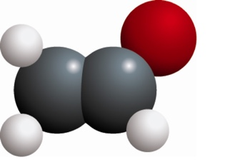A molecular element.
13. A lattice element.
14. A molecular compound.
15. A lattice compound.
16. **An atom consists of:**
17. a nucleus containing neutrons and protons, surrounded by a cloud of electrons.
18. central neutrons, surrounded by a cloud of electrons and protons.
19. electrons, surrounded by a cloud of protons.
20. a mixture of protons and electrons spread evenly in a neutral ‘dough’.
21. **Which of the following statements regarding atomic particles is false?**
22. Protons are found in the nucleus and are positively charged particles.
23. Electrons move around the nucleus and contribute little to the mass of the atom.
24. Neutrons are found in the nucleus and they have no charge.
25. The numbers of neutrons, protons and electrons are always equal in an atom.
26. **Identify which list contains only properties of metals.**
27. brittle, conduct heat, conduct electricity
28. malleable, electrical insulator, ductile
29. dull appearance, crumble, gas at room temperature
30. ductile, malleable, conduct electricity
31. **The following statements about elements are all true:**

* Elements are substances made up of just one type of atom.
* The atoms in elements can form molecules or crystal lattices.
* Elements can be metallic or non-metallic.
* Solid, non-metallic elements can be made up of molecules or crystal lattices.
* All solid, metallic elements are made up of crystal lattices.

**From this information you can deduce:**

1. A crystal lattice is always metallic.
2. A solid, non-metal element is always made up of molecules.
3. A solid element made up of molecules cannot be metallic.
4. A solid, non-metal is never made up of a crystal lattice.
5. **The chart below divides elements into 5 groups where the letters V, W, X, Y and Z represent an example of each.**

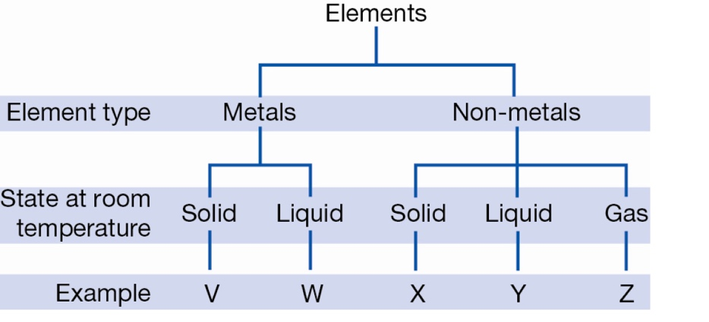**Given that bromine is the only non-metal liquid at room temperature, it can be inferred that bromine could be:**

1. Y only
2. W or Y
3. W only
4. X, Y or Z
5. **The conductivity of a metal is a measure of how well the metal transmits an electrical current. Usually, the conductivity will change with temperature as shown for four metals in the graph below.**

**According to this graph, the best conductor at 700°C is:**

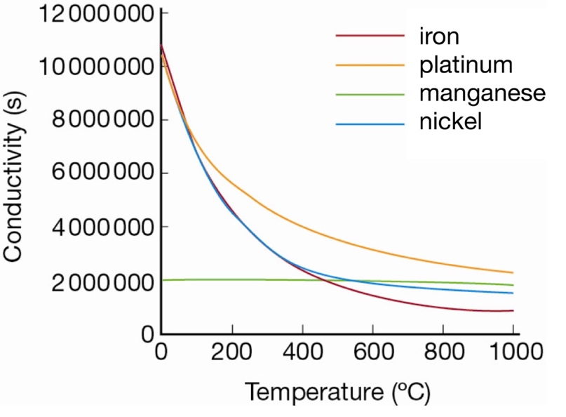

1. iron
2. platinum
3. manganese
4. nickel
5. **Elements in the periodic table are arranged in order of:**
6. decreasing atomic number.
7. decreasing mass number.
8. increasing atomic number.
9. increasing mass number.
10. **Table sugar (sucrose) has the formula C6H12O11. How many atoms are there altogether?**
11. 3
12. 17
13. 30
14. 29
15. **Which of the following is not a property of metals?**
16. Ductile.
17. Malleable.
18. Good electrical conductivity.
19. Having a dull appearance.
20. **Chemists use symbols to identify each element. Recall which feature is true of these symbols.**

a. They mostly contain one or two letters.

b. They always use the first letter of the element name.

c. They are arranged in the periodic table alphabetically.

d. They must use only capital letters.

1. **Which of the following lists contain only elements?**
2. aluminium, carbon dioxide, copper
3. iron oxide, carbon monoxide, boron
4. kerosene, hydrogen, mercury
5. manganese, hydrogen, lithium, boron
6. Given that an atom has 26 protons and 30 neutrons. Its atomic symbol would be:

30

26

56

26

Fe

Fe

A B

26

30

Fe

Fe

26

26

C D

1. **Which one of the following elements is a non-metal?**
   1. Iron
   2. Sulfur
   3. Zinc
   4. Copper

1. **Copper, iron and chlorine are all:**
   1. Mixtures
   2. Compounds
   3. Elements
   4. metals
2. **The correct symbols for the elements helium, hydrogen, magnesium and beryllium in order are:**

a. Hg He Mn B

b. He Hn Mn Be

c. H He Mg B

d. He H Mg Be

1. **Which of the following gives the correct charge of protons, electrons and neutrons?**
   1. PROTONS - negative, ELECTRONS - positive, NEUTRONS – neutral
   2. PROTONS - neutral, ELECTRONS - positive, NEUTRONS – negative
   3. PROTONS - positive, ELECTRONS - negative, NEUTRONS – neutral
   4. PROTONS - negative, ELECTRONS - neutral, NEUTRONS – positive
2. **Which of the following statements regarding Dalton’s atomic theory is not true:**
   1. All matter is made up of hard, tiny, invisible particles called atoms.
   2. Substances made from one type of atoms are known as compounds.
   3. The atoms of different elements can be distinguished by their different masses.
   4. Atoms can combine to form new substances called molecules.
3. **What change would need to be made to reduce the movement of particles in a substance?**
   1. Remove heat energy from the substance
   2. Remove magnetic energy from the substance
   3. Add heat energy to the substance
   4. Add electrical energy to the substance
4. **When a gas is stored inside a closed container, the gas exerts a pressure on the sides of the container. The amount of pressure is determined by:**

**1**    how frequently the gas particles hit the sides of the container

**2**    how fast the particles are moving when they hit the side of the container.

**If the volume of the container is halved, you would expect:**

* 1. the pressure to increase, because the particles have less room so will hit the side of the container more frequently.
  2. the pressure to increase, because the particles will travel faster.
  3. the pressure to decrease, because the particles have less room will hit the side of the container less frequently.
  4. the pressure to decrease, because the particles will travel slower

1. **Describe the particles in a solid.**
   1. The particles in a solid are strongly attracted to each other so the solid has a fixed a shape.
   2. The particles in a solid are strongly attracted to each other so the solid does not have a definite shape.
   3. The particles in a solid are weakly attracted to each other so the solid has a definite shape.
   4. The particles in a solid are weakly attracted to each other so the solid does not have a definite shape.
2. **Define melting point.**
   1. Melting point is the temperature at which a liquid changes to a gas.
   2. Melting point is the temperature at which a solid changes to a gas.
   3. Melting point is the temperature at which a liquid changes to a solid.
   4. Melting point is the temperature at which a solid changes to a liquid.
3. **Which of the following is true as a gas is changed into a liquid?**

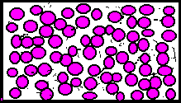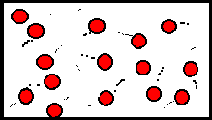

* 1. The temperature of the substance increases.
  2. The temperature of the substance decreases.
  3. The particles begin to move in rapid, random, straight line motions.
  4. The particles begin to take up more space.

**- End of Multi Choice Section -**

**Name: ________________________**

**Year 8 Chemical Science 2023**

**Mid Unit Test ANSWERS**

**Section 2: Short Answer Questions (28 Marks)**

1. **a) Write the name or chemical symbol for each of the elements below.**  (3 Marks)

Sodium: __Na____ Silicon: Si____ Fluorine: _F__

K: Potassium Ar: Argon Ne: Neon

1. **Name the elements that make up the following compounds**. (2 Marks)

Ammonium chloride - NH4Cl Nitrogen, Hydrogen, Chlorine

Aluminium hydroxide - Al (OH)3  Aluminium, Oxygen, Hydrogen

1. a) Calculate **the number of protons, neutrons and electrons in an atom with the atomic symbol:** (4 marks)

Protons: ___11

Na

23

11

Neutrons: __12

Electrons: __11

**b) Draw a LABELLED diagram of this atom including the number protons, neutrons and electrons in the correct locations:**

correct number of P, N, e 1 mk

correct position of P,N, e 1 mk

all parts labelled – nucleus, protons, neutrons, electrons 1 mk

correct electron configuration/shells 2,8,1 1 mk

1. **Name** **the element that is present in all of the following compounds.** (1 mark)

SO2, H2S, H2SO4, CuSO4

_____Sulfur________________

1. The diagram below shows a molecule of acetone, a colourless and flammable liquid often used to remove nail polish.

a) what elements are present in acetone? carbon, hydrogen, oxygen

(1 mark)

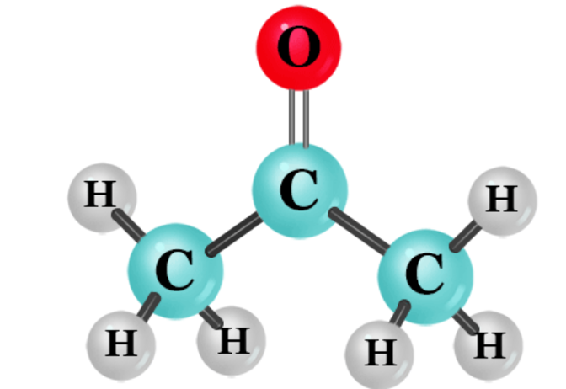b) the chemical formula formula for acetone can be written as Cx Hy Oz

x represents how many atoms? ____3______

y represents how many atoms? ______6_____

z represents how many atoms? _______1____

(1 mark)

1. **The following table shows information about three different elements. Use the information given in the table to help you fill in the missing details.** (5 marks)

|  |  |  |  |  |  |  |
| --- | --- | --- | --- | --- | --- | --- |
| Atom | Atomic number | Mass number | Number of protons | Number of neutrons | Number of electrons | Symbol for the atom |
| Mercury | 80 | 201 | 80 | 121 | 80 | Hg |
| Magnesium | 12 | 24 | 12 | 12 | 12 | Mg |
| Helium | 2 | 4 | 2 | 2 | 2 | He |

1. **The diagram below shows models of water molecules.** (2 marks)

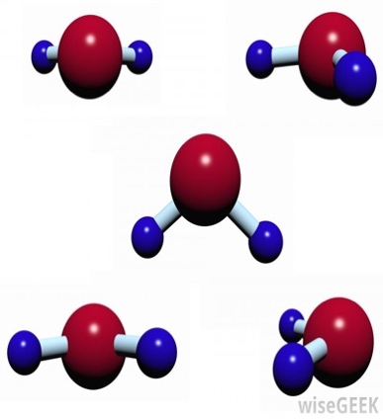

**a) Explain what is meant by the word “molecule”.**

____A group or cluster of atoms bonded/attached together

______________________________________________

**b) Is water an element or a compound?**

______Compound_________________

1. Bradley put a balloon over the top of a lemonade bottle on a cool day. The bottle and the balloon contain air particles, as shown in the diagram below.

He put the bottle into some hot water and observed that the balloon changed.

1. **Draw** **the balloon** and the bottle after they were put into hot water to show what happened to the air particles inside. *(There are 20 air particles)*

(2 Marks)

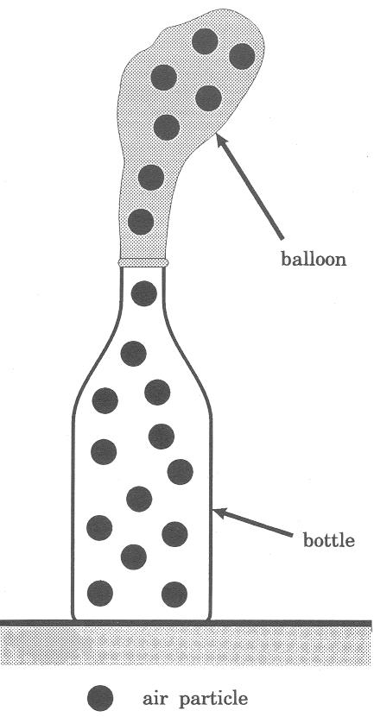After placed in hot water:

Balloon has expanded (1 mark).

Same number of particles with increased space between them (1 mark).

1. **State** what caused the balloon to change. (1 Mark)  
   ______Increase in ‘heat’/ ‘temp’ (½ mark)

or particles gained energy (1 mk)

1. Using the Particle Theory, **Explain** what happens to the air particles when they are heated? (2 Mark)

Particles are moving faster (1 mark)

Particles are spreading further apart (1 mark)

**9. The following dagram shows an experiment in which a student places water in a syringe then pushes against the plunger.**

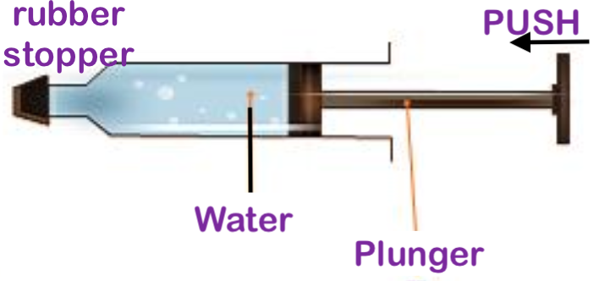

a) **Describe** what will happen? the plunger will not move (1 mark)

b**) Explain** the above observation: very little space between water particles/molecules so the particles can not move closer (1 mark)

Note: (Under ridiculously extreme pressure water can compress only slightly – but not by a student pressing a plunger)

c) The experiment is repeated with the water replaced by air. **State** what will happen and **explain** what will happen in this experiment. (2 marks)

Observation – air is compressed/plunger moves in (1 mark)

Explanation – there is much space between particles (1/2) to they can move closer together (1/2) when the plunger is pushed in

**END OF TEST**

**MULTI CHOICE: /25**

**SHORT ANSWER: /28**

**TOTAL: /53**